It’s Panto Time!
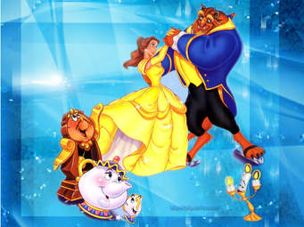
Oh yes it is; the Dolphins have chosen Beauty and the Beast, written by Ben Crocker – his panto scripts are a firm favourite with many amateur dramatic societies including the Dolphins. Last year Ben's panto scripts were performed all over the UK and Ireland - and in Canada, USA, Australia, New Zealand, South Africa, India, Hong Kong, Saudi Arabia, Hungary, Greece, Belgium and France. The quality and sheer sense of fun know no boundaries!
Due to the forthcoming refurbishment of the Dolphins Hall we have been advised to make other arrangements; so this autumn will see the Dolphins performing in a different venue. A BIG thank you to The Goods Shed for opening their doors to us, yes that’s right The Dolphins Dramatic Society will be performing Beauty and the Beast at The Goods Shed from Thursday 22 to Saturday 24 November with two performances on the Saturday. Anne Smith will be directing the production and of course Jenny Miles will be assisting her, so you know you’re in for a real treat with plenty of laughs, colour and audience participation. The story of the Pantomime Beauty and the Beast is slightly different, the childhood classic you have come to love is still a tale of finding love where you least expect it, about seeing with your heart and is complete with a needy witch, it does include some animated furniture and a talking poodle, yes that’s right a talking poodle with a French accent! If you want an evening of fun and laughter, don’t forget to put those dates in your diary.
Terri White

