Dolphins Dramatic Society
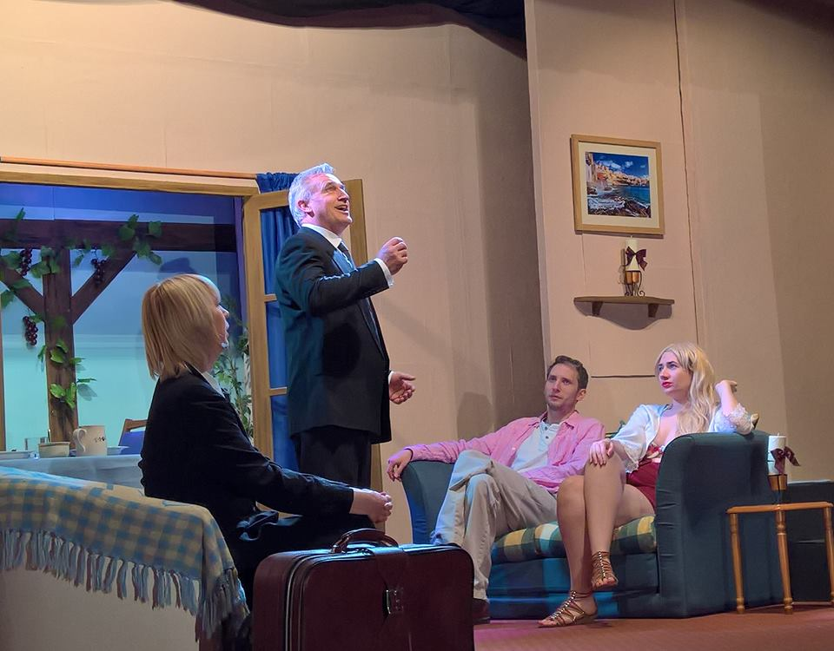
Didn’t they do well! A fantastic production, Jackie, Gwen, Amelia, Alex, Steve and Vincent were all absolutely brilliant. The timing was good and the humour came across really well. Amelia was very brave wearing just shorts and a bikini top (she looked gorgeous didn’t she), both she and Gwen were carried hither and thither as dead bodies – hope the two of you didn’t get lots of bruises. Everyone played their part so well, excellent work. If you didn’t come to see the play, you missed out on a great evening.
As always there are several people to thank:
IHS Markit – Matt the printing was perfect as always
Ken White – putting the programme together, he is not a Graphic Designer and he still did a fantastic job.
David Hudson – he travels from Cornwall to help the Dolphins with sound and lighting for both autumn and spring productions. He always puts his heart and soul into it which results in first class sound effects and lighting – simply the best.
Tetbury Hardware – Malc you are just magic as The Dolphins box office.
All the traders that placed an advert in our programme.
The Snooty Fox and Tetbury Town Council for displaying our promotional banner and to the shops who displayed a poster.
A special thank you to the people of Tetbury and those that were visiting who came to see the show.

Now we must move forward to the next production. All members of the Dolphins Dramatic Society have cast their vote for the pantomime, I can hear you all groaning ‘she’s talking about winter already.’ Oh yes I can! We know what you Tetbury people are like, you need to get dates nice and early as you’re such busy people. Get those pens and diaries out and note it down - the pantomime is, Sleeping Beauty and it will run from Thursday 23 November to Saturday 25 and yes there will be the special night organised by Tetbury Lions for all the older people of Tetbury on Wednesday 25 November. "Sleeping Beauty" (French: La Belle au bois dormant "The Beauty Sleeping in the Wood") by the Brothers Grimm, is a classic fairy tale which involves a stunning princess, a sleeping enchantment, and a handsome prince. This beautiful story has been adapted for pantomime by Ben Crocker, the king of panto scripts, so you know it will be funny, have plenty of audience participation and all will end happily ever after!

