Dolphins Dramatic Society
There is murder in the air but don’t worry folks, it’s not serious they just keep losing the body!
‘Anybody For Murder’ is a comedy bordering on farce and it really is funny, I can vouch for that as I have sat in on a couple of rehearsals now. The cast have really gelled and are all strong characters so you are in for a real treat, don’t forget 6, 7, 8 April 2017 and tickets will be on sale in March at our usual Box Office – Tetbury Hardware, London Road. There is only a small cast for this production, a total of just six, so as you can imagine they have all got a lot of lines to remember – so as well as remembering their moves on stage, which side or door to come in by, they are also busy learning their lines too; no mean feat when one realises they all work full time. They are also responsible for their own costumes – busy, busy people.
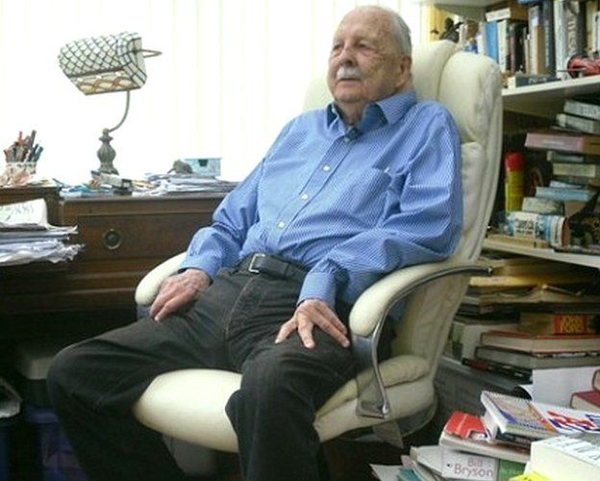
The humour in this play is typical of scripts written by Brian Clemens and Dennis Spooner. Brian Clemens, from the mid-1950s onwards, was a staff writer for the Danzigers, churning out dozens of quickie scripts for assembly-line 'B' movies and half-hour television series such as Mark Saber, White Hunter, The Man from Interpol, Richard The Lionheart and many more, his output was so prolific during the late 50s and throughout the 1960s that he frequently used the pseudonym Tony O'Grady. Clemens met up with Dennis Spooner during the 60s, an accomplished writer responsible for: Harry Worth, Bootsie and Snudge, No Hiding Place and Ghost Squad to name but a few.
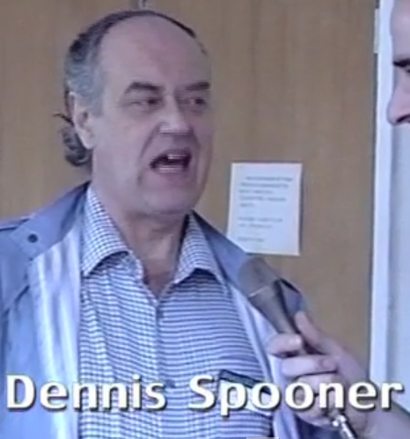
Clemens and Spooner struck up a partnership that lasted for the rest of Spooner's career. Clemens offered the young writer work on The Avengers which was near the beginning of its nine-year run on ITV. Clemens bought two more of Spooner's scripts in that first year, making Spooner a fairly important writer during the Ian Hendry era of the programme. They collaborated on four scripts all of which included their quick wit and comedic flare making the plays a real pleasure to watch. Sadly both men are no longer with us but the legacy of entertainment they have left is just amazing.

So now you know the play is well written, is really funny, has twists and turns you don’t expect, an excellent Director in Anne Smith and a fantastically strong cast. What more could you wish for, for a great night out!

Urgent - we are looking for some items of furniture for the set. Namely a small wooden table and two chairs, a ‘wooden look’ unit with drawers if possible; also a small modern style armchair or tub chair. They will be well looked after. If you can help please call Anne Smith:
0788 737 7139.

