Dolphins Dramatic Society
Come November the nights will have drawn in, the temperature dropped (not that it has been particularly hot this summer) and all of us will be wistfully thinking of sunshine and lighter nights. So The Dolphins Dramatic Society has decided to put on a musical that will make you feel warmer, cheer you all up and make you smile. The production this winter is Summer Holiday! I am sure there are many of you who remember the film version from 1963. What a year that was - Beatlemania was born, the Profumo affair scandalised Britain and preceded the resignation of Harold Macmillan; Ronnie Biggs, Buster Edwards and co. snatched £2.6m cash from the London to Glasgow mail train and the ‘Britain in Bloom’ campaign began.
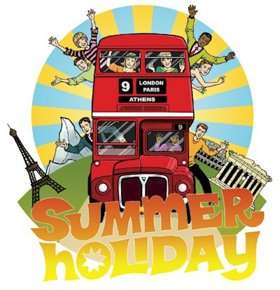
The stage play was adapted from the film by Michael Gyngell and Mark Haddigan in 2003 with the idea that instead of relying on technology as films do to produce a smooth, seamless or thrilling production; the stage version would be exciting, surprising and give you the audience the opportunity of using your imagination. Those of you who remember 1963 will have the chance to hear all those catchy songs AND to sing along with them too. Come on you know the ones – `Do You Wanna Dance,’ `On the Beach,’ ` In the Country and of course `Bachelor Boy!’ For those of you who haven’t got a clue what I’m talking about, read the October edition of the Tetbury Advertiser and I will tell you the story. In the mean time put these dates in your diary: 26th – 28th November and come and bathe in the nostalgia and fun of Summer Holiday. There will of course be the special performance for all the older people of Tetbury, which will take place on Wednesday 25 November and is very kindly organised by Tetbury Lions. By the way if there are any young people between the ages of 18 and 30 who would like to be part of this production, do call Anne Smith on: 0788 737 7139.

