Dolphins Dramatic Society
Well by the time this hits your doormats the Society will only have two weeks to go aagh!!! As usual everyone has been really busy either learning lines, sewing or painting scenery. Jason has created his usual master piece with the scenery; these plus stone columns which have been loaned from Gardens of Stone of Tetbury will ensure you really will feel you are in Greece. Jenny and Anne have been beavering away making the costumes, as you can see from the photo they are very colourful and what is really great about them is they hide a multitude of sins!
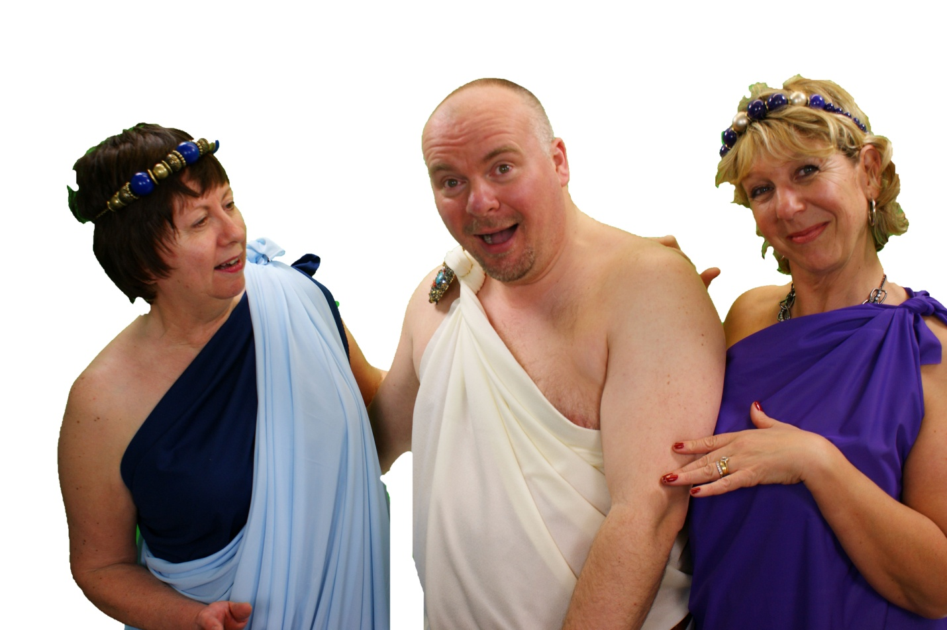
Anne Smith, Steve Scott, Annette Farrow
Rehearsals have had their ups and downs but as always as time marches on it all takes shape, by the time it gets to the performance dates, the adrenalin kicks in and as the saying goes `it will be alright on the night!’ Tetbury will have a show with a difference and one to remember. Seating will be groups of tables and chairs all beautifully adorned with table cloths and flowers, this plus a nice bottle of wine (on sale from the bar) will make for a very convivial night out. The Dolphins have been really lucky and have Jonathan Adkins on board again as Musical Director – his playing is superb and ensures that all the cast keep up with the chorus and compliments Gwen’s voice when she sings some of the verses solo. In fact you will probably want to join in the chorus of one of the songs, you will know the words `Keep Young and Beautiful.’
Don’t forget Gala Night on Wednesday 11 May, it will give you the opportunity to relax in the wonderful surroundings of The Close Hotel, enjoy a gorgeous 3 course meal and be entertained – all for just £20. It is a black tie `do’ so gives you a good reason to put your `glad rags’ on. It will be a rip roaring night, 7.00pm for 7.30pm start, rounded off with a good old sing song. So hurry up and buy your tickets to avoid disappointment -call Annette Farrow on 01666 502900.
The Dolphins would like to say a special thank you to all the traders of Tetbury (and one in Nailsworth) who have so kindly placed adverts with the Society, the money from the adverts helps to buy props, material for costumes and any new equipment we need. Everyone is so gracious when called. The Dolphins really do appreciate your support and we hope in turn you all receive business from these adverts. They do look posh don’t they – Janet Grzyb does a fantastic job and she always manages to find some really interesting snippets that link with whatever production is taking place.
Rob and Ian Smith have between them written and directed Greek Fire, they are also kept busy with their group of travelling storytellers, Limited Company - Limited Only by Your Imagination. Formed in 1996, Limited Company has entertained many audiences with a unique collection of stories and monologues, performed without stage or scenery. Their material can be challenging: almost entirely comprised of solo pieces, some very short but each designed to establish a character with a story to tell and, sometimes, a message to convey. The repertoire extends to over 200 scripts, which might be funny, romantic, nicely naughty or frightening, even a Murder Mystery. Limited Company welcomes invitations to perform for local groups or charities and can be contacted on 0789 6658 964.
Well folks that’s about it for now, remember to hurry down to Russells Dry Cleaners and get your tickets for Greek Fire, you have only three nights to choose from Thursday 12, Friday 13 and Saturday 14 May. Prices are still the same £9 for adults and £5 for concessions – a bargain for a Good Night Out!

